

COURSE NAME: Algorithm Analysis

STUDENT: Ertuğrul ŞENTÜRK

HOMEWORK SUBJECT: Usage of Hash Algorithm

ALGORITHM:

1. Load factor and hash table were taken as input from the database, if file does not exist an empty hash table was created. Load factor value is taken as 0.
2. An input taken from the user for method.
3. For input 1 we get a file name from the user and read it.
4. If the word exists in the hash table, the name of the document is added to its struct, otherwise a new word is added to the first empty index that results from the hash value.
5. While adding the word, how many steps it taken and the current table occupancy rate were printed to the user.
6. For input 2 we get a word from the user.
7. The word was searched in the hash table, if any, the documents containing the word, if not, the user was informed that the word could not be found.
8. We printed how many steps to search it taken.
9. For input 3 the hash table is cleared. The load factor is reset, and the empty table values ​​are saved in the database file.
10. For input 3 the text on the screen has been cleared.
11. For input Q memory deallocated and program terminated.

Complexity:

1. If we assume the word count in the file is n, finding a word’s hash value and putting into the table has in theory O(1) complexity. For all words it has O(n) complexity.
2. Finding a word in the hash table also has in theory O(1) complexity.

Screenshots:

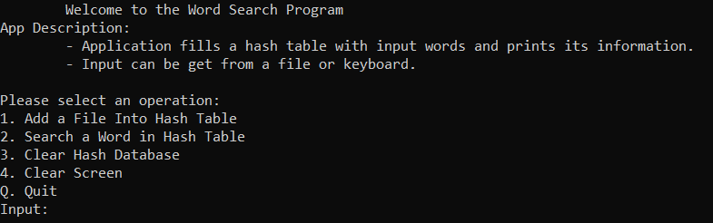

Welcome Screen

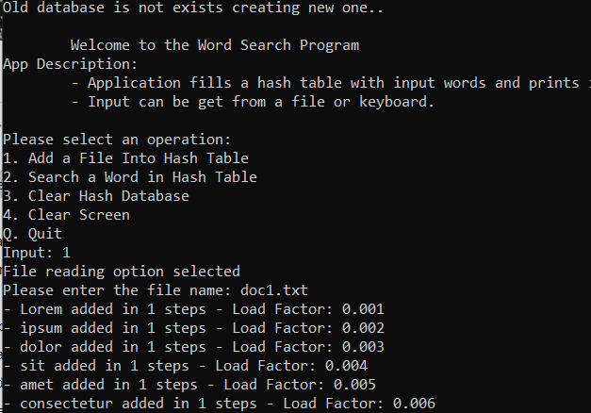

A dding a New File

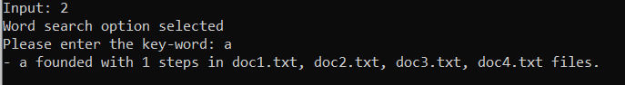

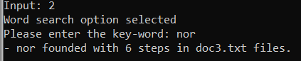

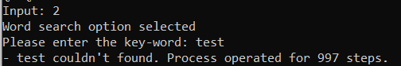

Search Samples

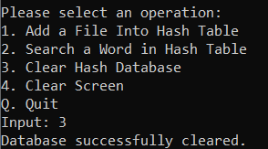

Clearing Database

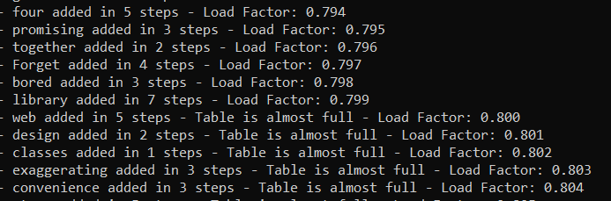

Table Almost Full

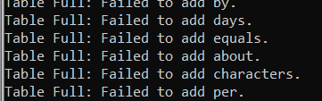

Table is Full